Question 2-

<https://youtu.be/oN-JKhEceMk>

As we know database migration is a process to migrating data from source databases to destination database .

In GCP also provides Database migration API’s as part of there cloud services.

To start the database migration Navigation Menu--> Database migration--> Enable

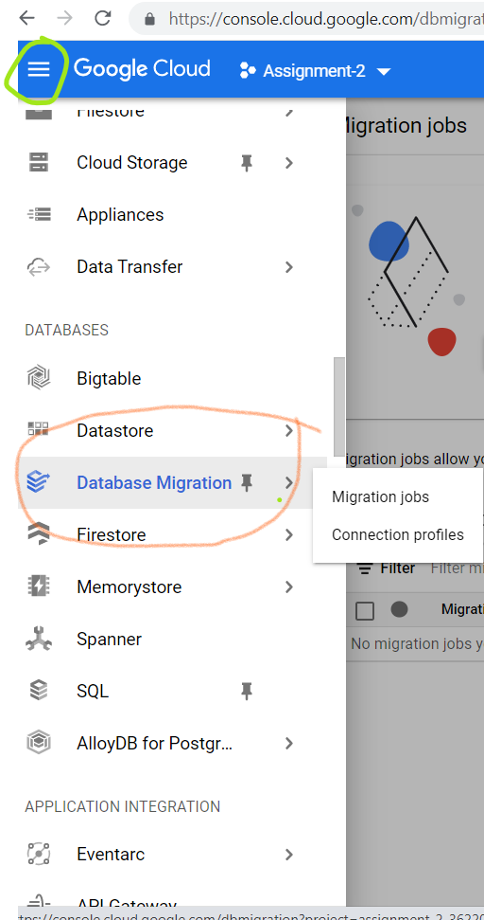

To start a migration process job we need to mentioned the source, destination and test connection followed by start migration.

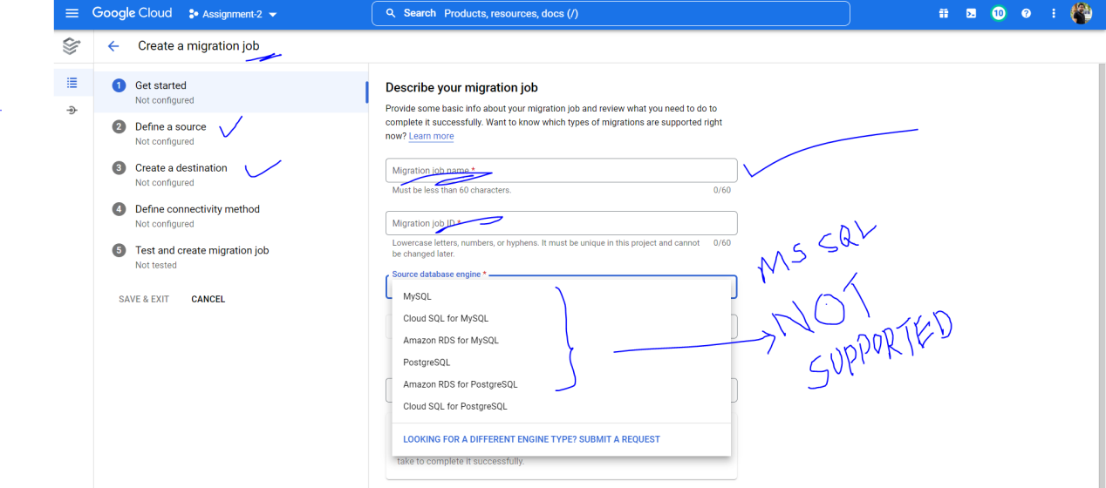

As of now GCP provides some of the specific databases like MySQL, PostgreSql etc.

As per defined in the question we need to migrate the data from Sql Server database to Mongodb and vice versa. As SQL server is not fully supported from GCP cloud (SQL Server beta version only available for Paid tier customers), I am using another GUI studio 3t for that service.

**Step 1:**

* Create new connection and add external Ip from GCP VM(m20aie252-mdb) as server and port 27017 along with authentication as an username and password.

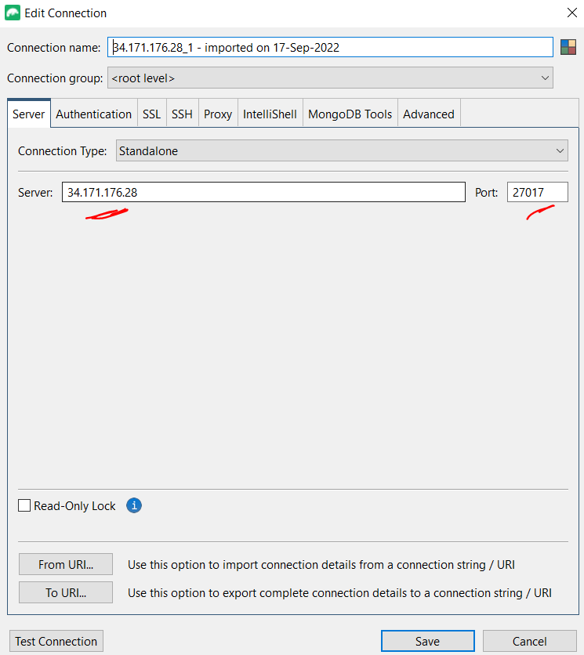

* Created new database test and Collection staff.

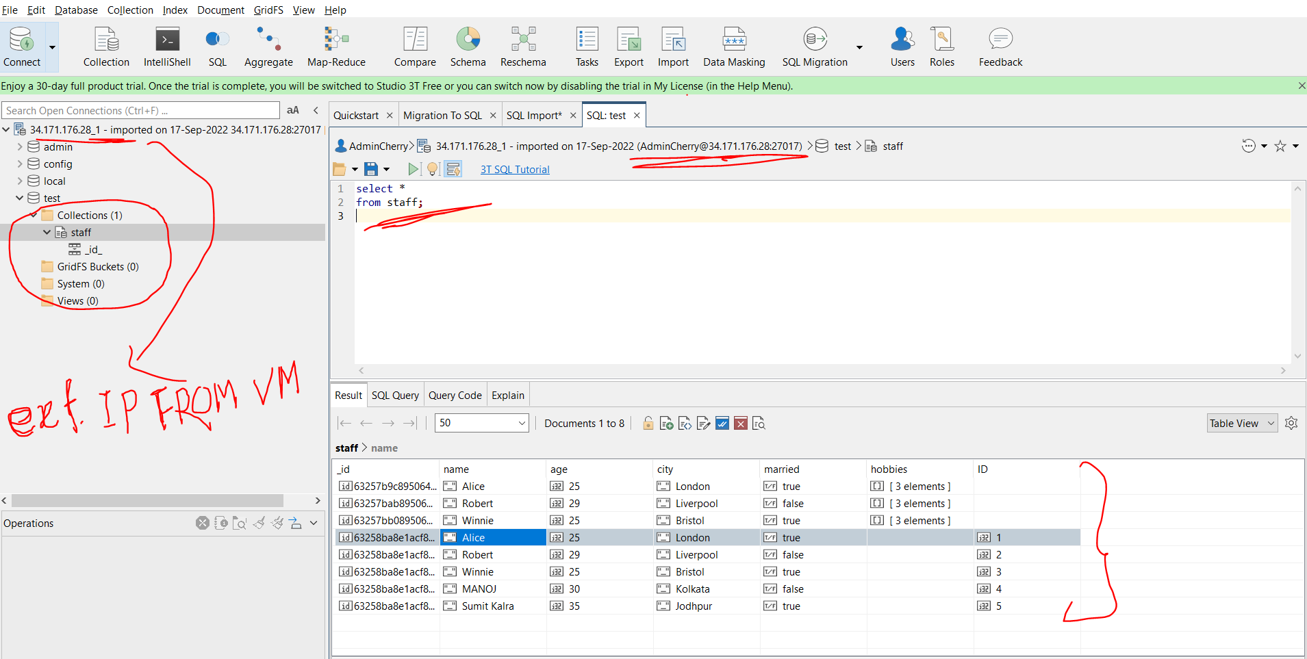

**Step 2:**

**Migration data from MongoDB to SQL Server-**

* Right click on database test and Select SQL Migration--> MongoDB to SQL Migration

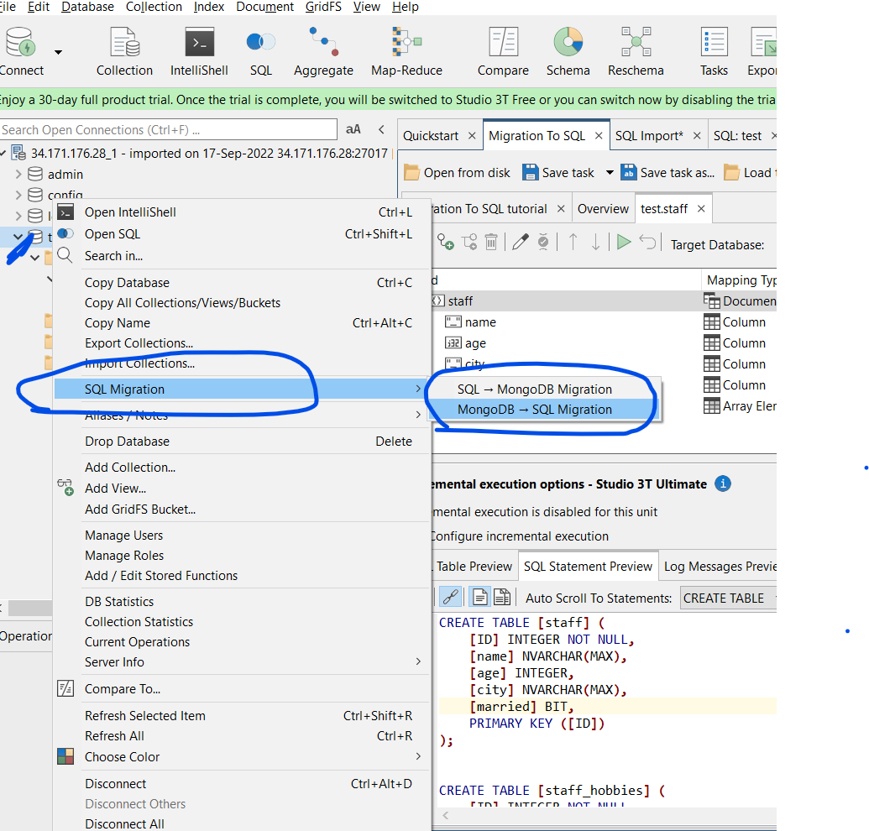

* In Overview Selected Type as Microsoft Sql Server and Sql target connection server and after that select Click here to connect a server (Provide host ,username, database etc.)

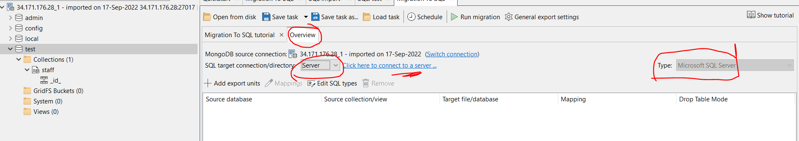

Connect to server-> Test Connection

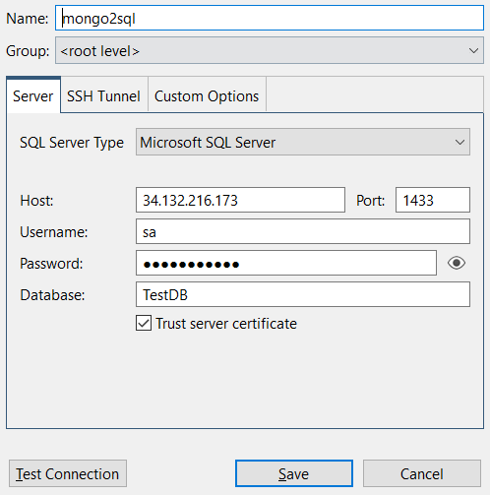

Add Export Unit --> Collection name--> Mapping--> Preview

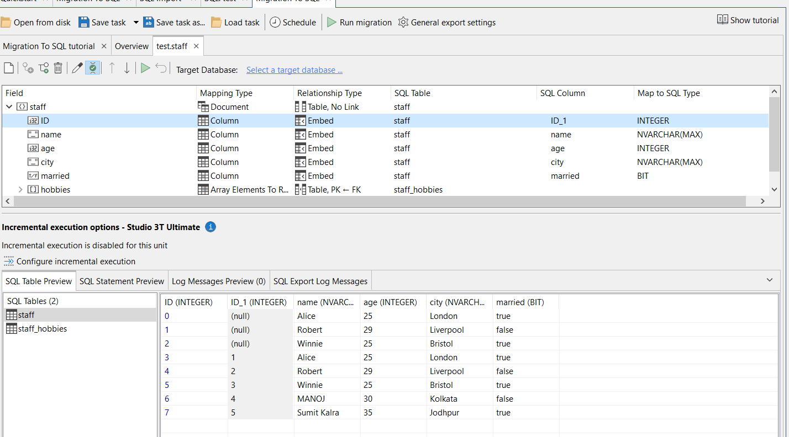

* After mapping the columns select the target database as below -

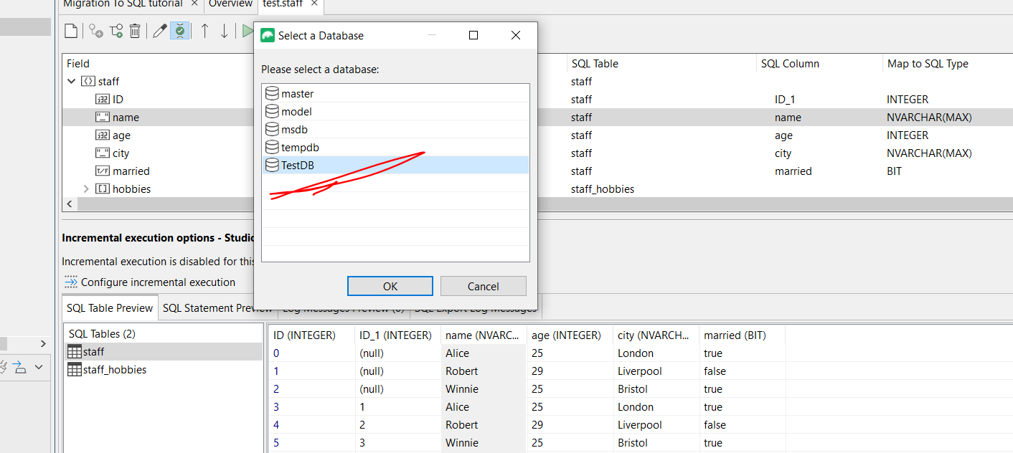

* Click Run Migration and It will migrate all of the data to SQL Server.

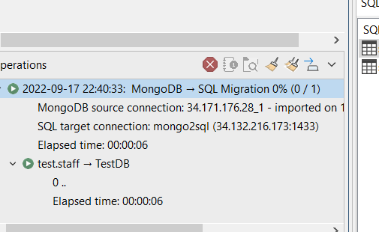

* As you can see tables and data both are migrated from mongo db.

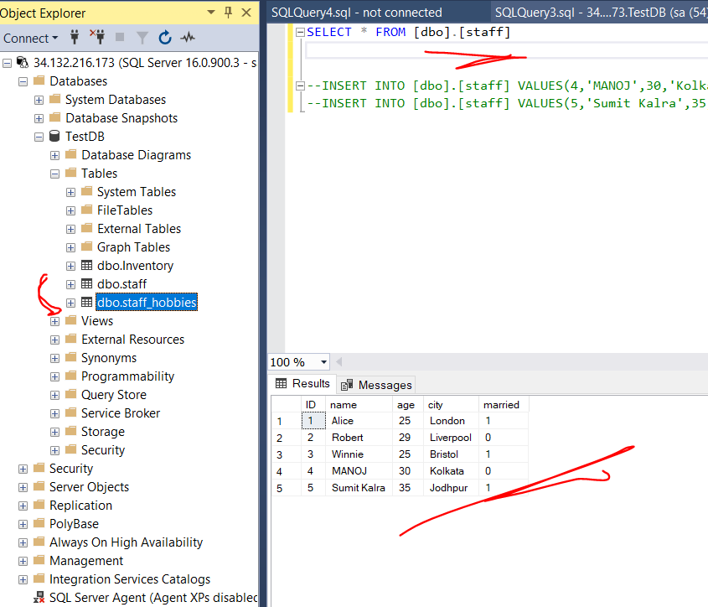

* Now lets change some data in the SQL Server Database (adding new record) and next step I am migrating vice versa from sql to mongodb.

**Step 3:**

**Migration data from SQL Server to MongoDB -**

* I created two new record inside staff table and now we will migrate that from sql server to mongodb.

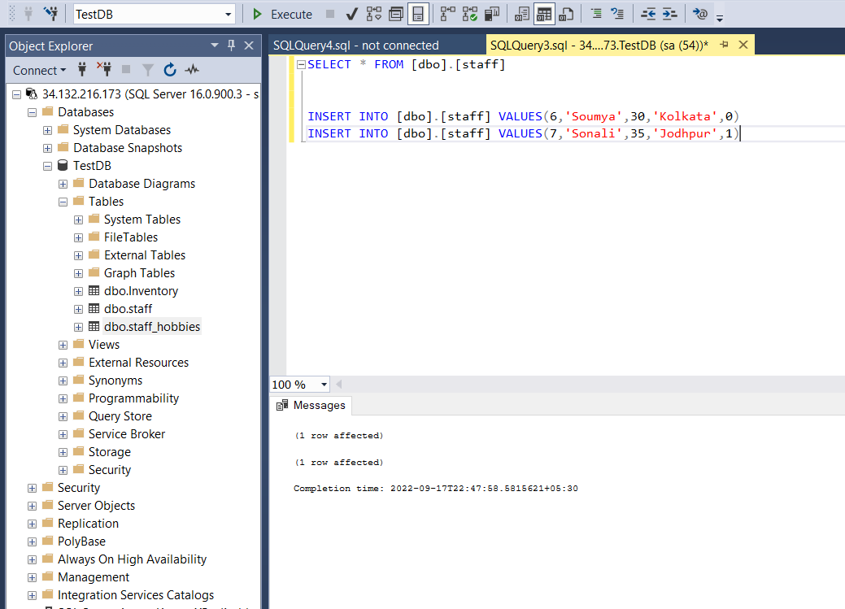

* Selected database test inside studio 3t explorer and select sql migration followed by sql to mongo db migration.

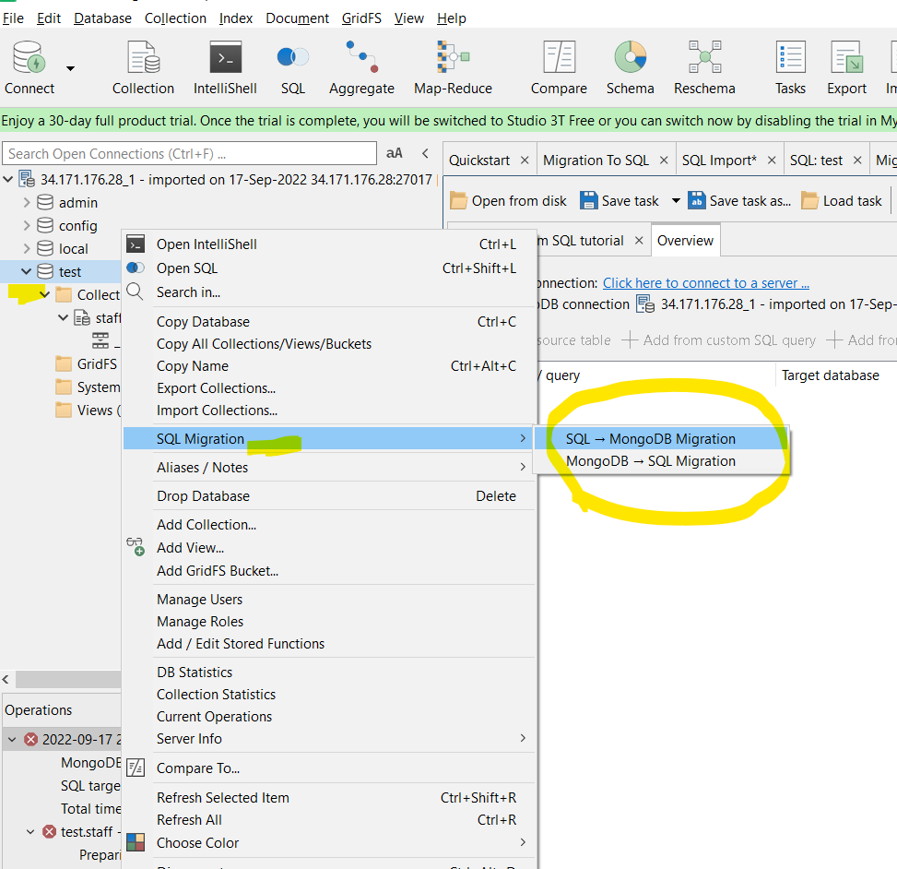

* Selected Source SQL Connection and database name as I explained above in step 2.
* Add From Source Table--> Mapping

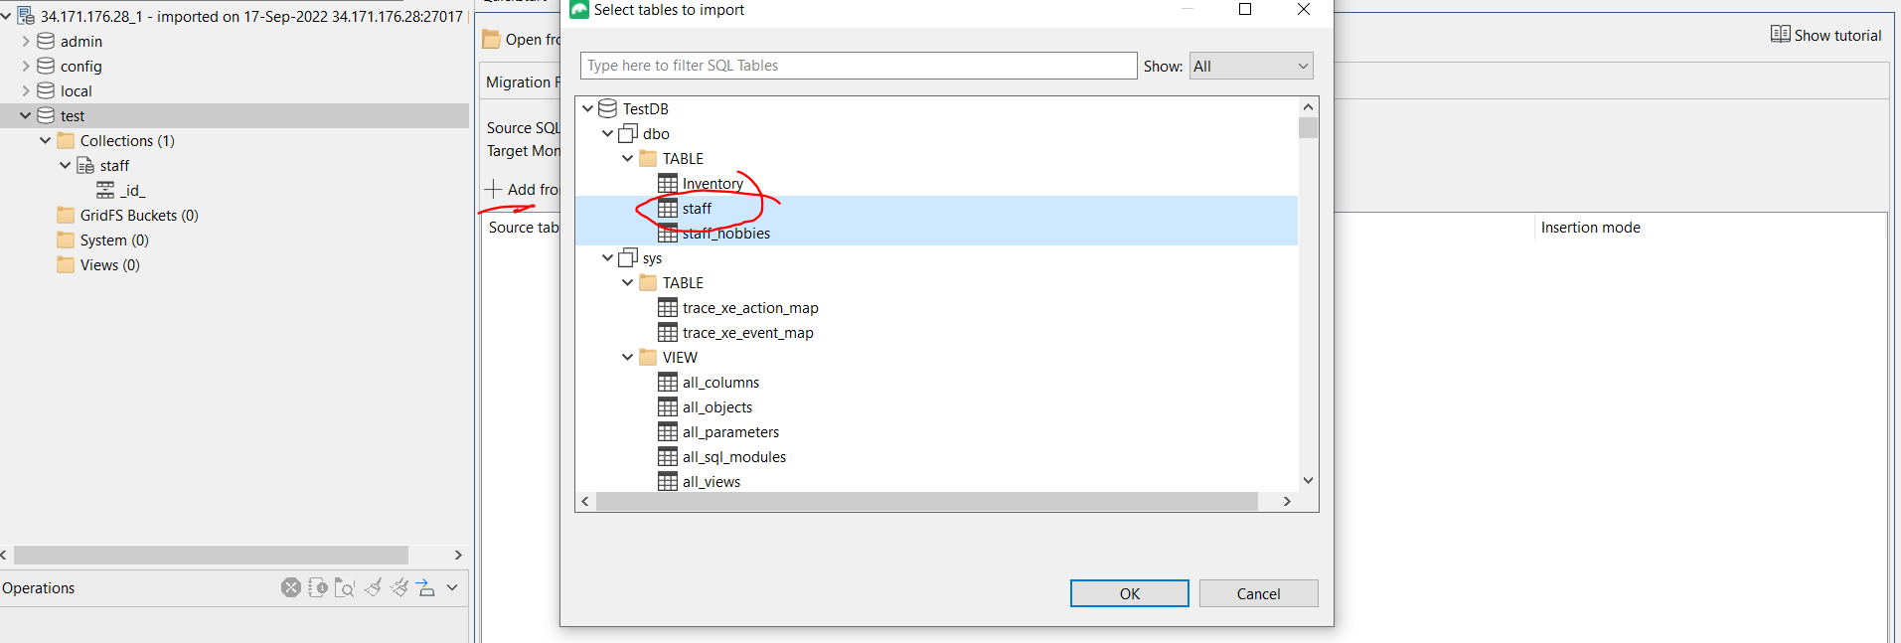

* Selected Run Migration and Migration Completed successfully.

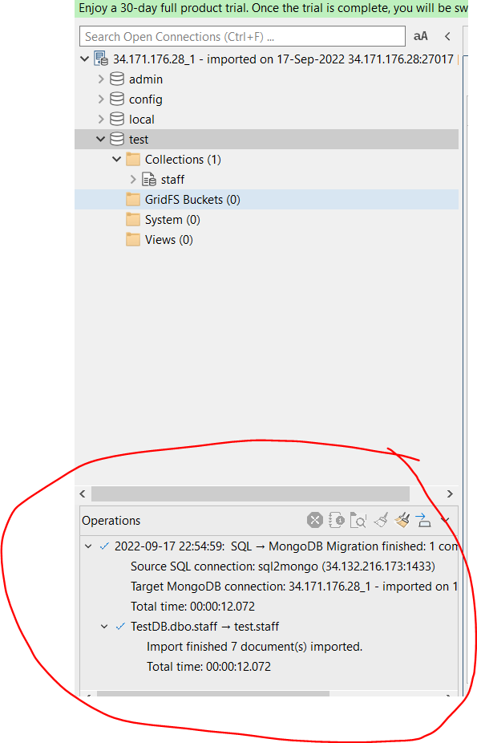

* For latest record in mongo db I queried and here is the result.

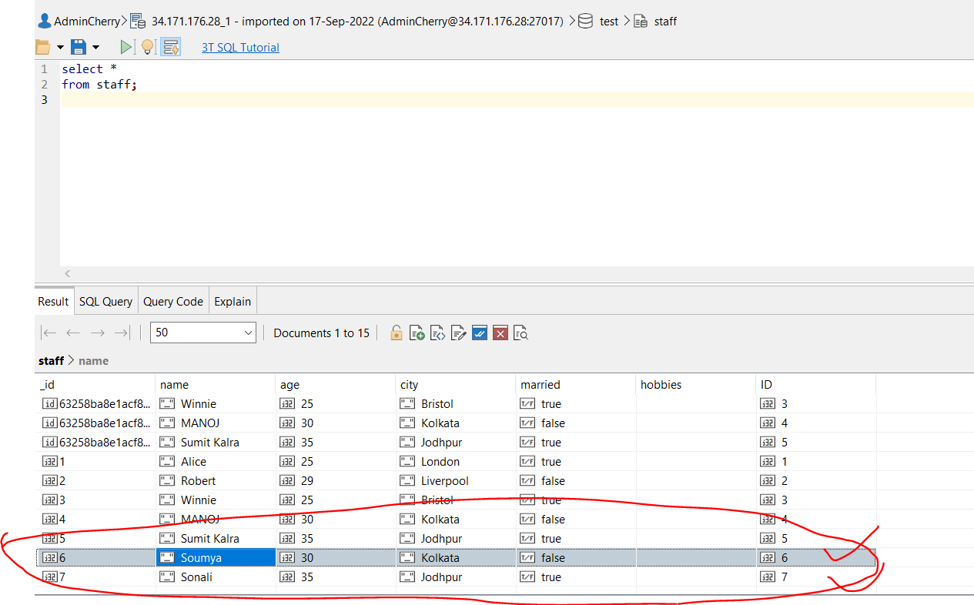

Here you can see the latest record after successfully migration data from sql server to mongodb.